Substances of Use and Abuse: Alcohol, Tobacco, Vaping, Marijuana (smoked, edibles, vape), Opiates (prescription drugs, heroin), Methamphetamines, Cocaine, Hallucinogens, Inhalants, Synthetics (K2, Spice), Tranquilizers and Sedatives, Cough and Cold Medicine
Bucks County Drug & Alcohol Commission, Inc.
600 Louis Drive, Suite 102-A
Warminster, PA 18974
215-773-9313

Items to Look For:

- Tin foil
- Tiny balloons
- Visine
- Brown or white powdery substances
- Butane lighters
- Vape pens, oils
- Small baggies often with a stamp on it
- Syringes (or orange cap from syringe)
- End of cigarette butts
- Missing spoons or spoons with blackened bottom
- Missing prescription drugs
- Missing alcohol or cigarettes
- Disappearance of money or valuables
- Smell in car, drug paraphernalia in car
- Pipes, rolling papers, small medicine bottles
- Unusual containers, wrappers, or seeds left on surfaces (used to clean marijuana like frisbees)

Behavioral Changes to Look For:

- Mood changes
- Change in relationship (family and friends)
- Changes in behavior and personality
- Loss of interest in school and activities
- Concerns voiced by others
- Police contact
- Truancy
- Frequently breaks curfew
- Going out every night
- Asking for money (cash flow problems)
- Aggression
- Irritability
- Change in sleeping patterns- up all night, sleeping during the day
- Change in hygiene habits
Physical Changes to Look For:
- Change in pupils
- Clenching teeth
- Nosebleeds/runny nose (not caused by allergies or cold)
- Sores, spots around mouth
- Unexplained physical health problems
- Wetting lips or excessive thirst (known as cotton mouth)
- Sudden or dramatic weight loss or gain
- Accidents/injuries/skin abrasions
- Sweatiness
- Slurred speech
- Gaunt and pasty skin
- Unusually tired

Common Household Items Used:
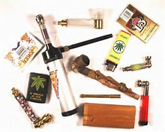
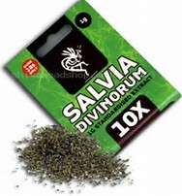
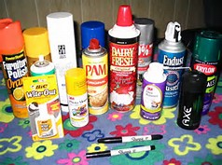
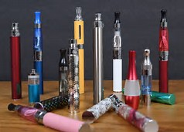
Huffing/Inhalants:
Nail polish, whipped cream and markers

Medicine Cabinet:
Cough and cold medicine, antihistamines,
mouthwash, hand sanitizers, laxatives, and diet pills

Kitchen Cabinet:
Nutmeg and Vanilla Extract, and
energy drinks
Have a Child Age 12 and up to 17 with an Alcohol or Drug Problem?
\\chisilon\dnawordusers$\control copy folders\narcan toolkits\signs symptoms of drug use abuse- 4-17.docx
Wonder where to turn?
We can help, by providing information on community and family resources, support groups, school services, etc.
And….If your child refuses treatment, there is another option. The legal system can require your child to enter drug and
alcohol treatment. To get the process started, call the Bucks County Drug & Alcohol Commission, Inc. (BCDAC, Inc.)
at 215-773-9643 and mention Act 53.

What is Act 53?
ACT 53 is a law in the state of Pennsylvania. Act 53 allows a parent/legal guardian to get a drug and alcohol assessment for their child, and if warranted, compel the child to enter treatment.

Criteria
• The parent/legal guardian believes that their child has a drug or alcohol problem;
• The child is unwilling to participate in a treatment program;
• The child must be a resident of Bucks County; and
• The child must be between the ages of 12 and up to 17
If the above criteria are met, BCDAC, Inc. will guide the parent/legal guardian through the Act 53 process.

Questions? For more information about the process, please contact:
Bucks County Drug & Alcohol Commission, Inc. 215-773-9643, M-F 8:30-4:30 OR
Bucks County Children’s Crisis Support 1-877-HELP (1-877-435-7709), After Hours
Helpful Tips!
- Communication- Talk to your children frequently about drugs and alcohol (use opportunities like time in a car)
- Check vehicles, cell phones, pockets, bags, and rooms
- Know your children’s friends and their parents
- Model behavior, pay attention to how you model drinking at home
Helpful Links: http://www.buckscounty.org/LivingAndWorking/drugandalcoholcommission, www.pastop.org , https://www.samhsa.gov/, https://www.drugabuse.gov/, http://abovetheinfluence.com/

